**COSC344 Assignment 2**

**Team:** Group4

**Leader:** Mark Young

**Members:** Mark Young, Poppy Dickson, Stephen Joe, Qianying Zheng

1. **Revised ER Diagram**

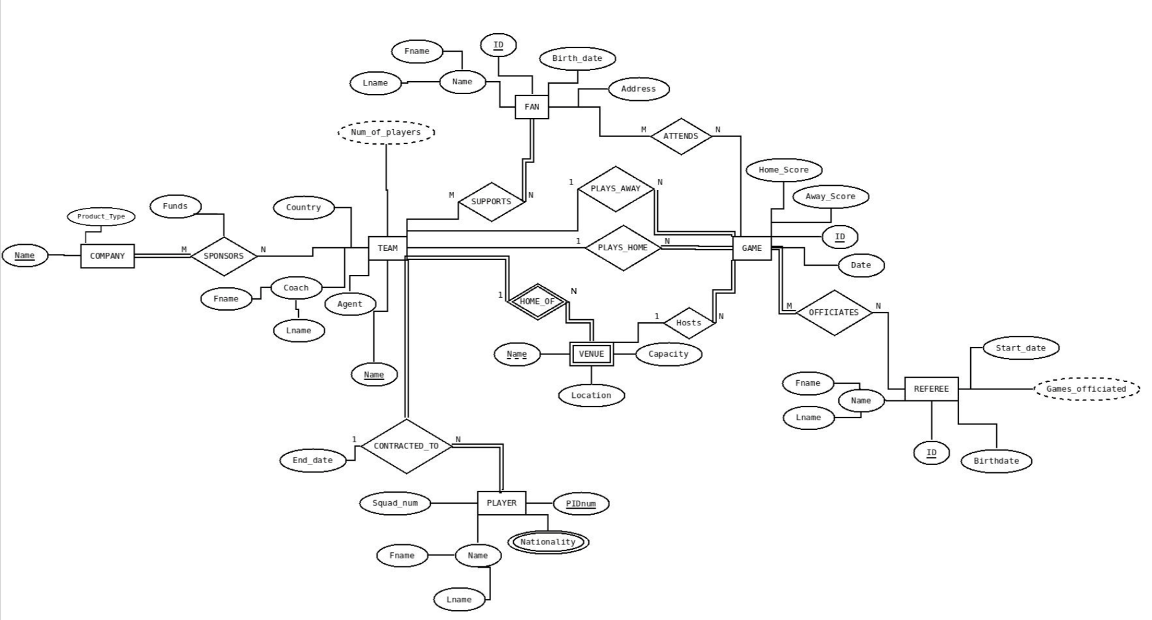

**Changes to the ER Diagram**

* **Plays relationship:** The plays relationship was split into two new relationships **Plays_Away** and **Plays_Home**. This was done to specify which team is the home team and which is the away team. This is both used to gain statistics on which teams host the most games, and can be used to calculate a home field advantage. Both were given 1:N cardinality, as only 1 team is home and 1 is away in a game, but a team may play any number of games as home or away. A Game must have a home team and an away team, so the Game side has total participation, but a Team is not required to be home or away, so the Team side is partial participation.
* **Winner attribute of game:** Winner was split into **Home_Score** and **Away_Score**. This was done to collect scoring data, as opposed to just a binary win or loss.
* **Type attribute of Company**: Type was renamed **Product_Type**. The name was changed to make the attribute more easily understood by people reading the ER Diagram. It was also made single valued, as a Company only makes 1 type of product.
* **HOME_OF** **Relationship:** The right cardinality was changed from 1 to N, as it was decided that a Team could have multiple Venues, for example a training stadium and a game stadium.
* **Hosts Relationship:** The Hosts relationship was added to indicate which Venue hosted each Game. Only 1 Venue hosts 1 Game so the left cardinality is 1. The right cardinality is N, since a Venue may host multiple Games. It is total participation on Game side, as each Game must be hosted, but partial on Venue, as Venues do not necessarily have to host a Game.

**2. Relational Schema**

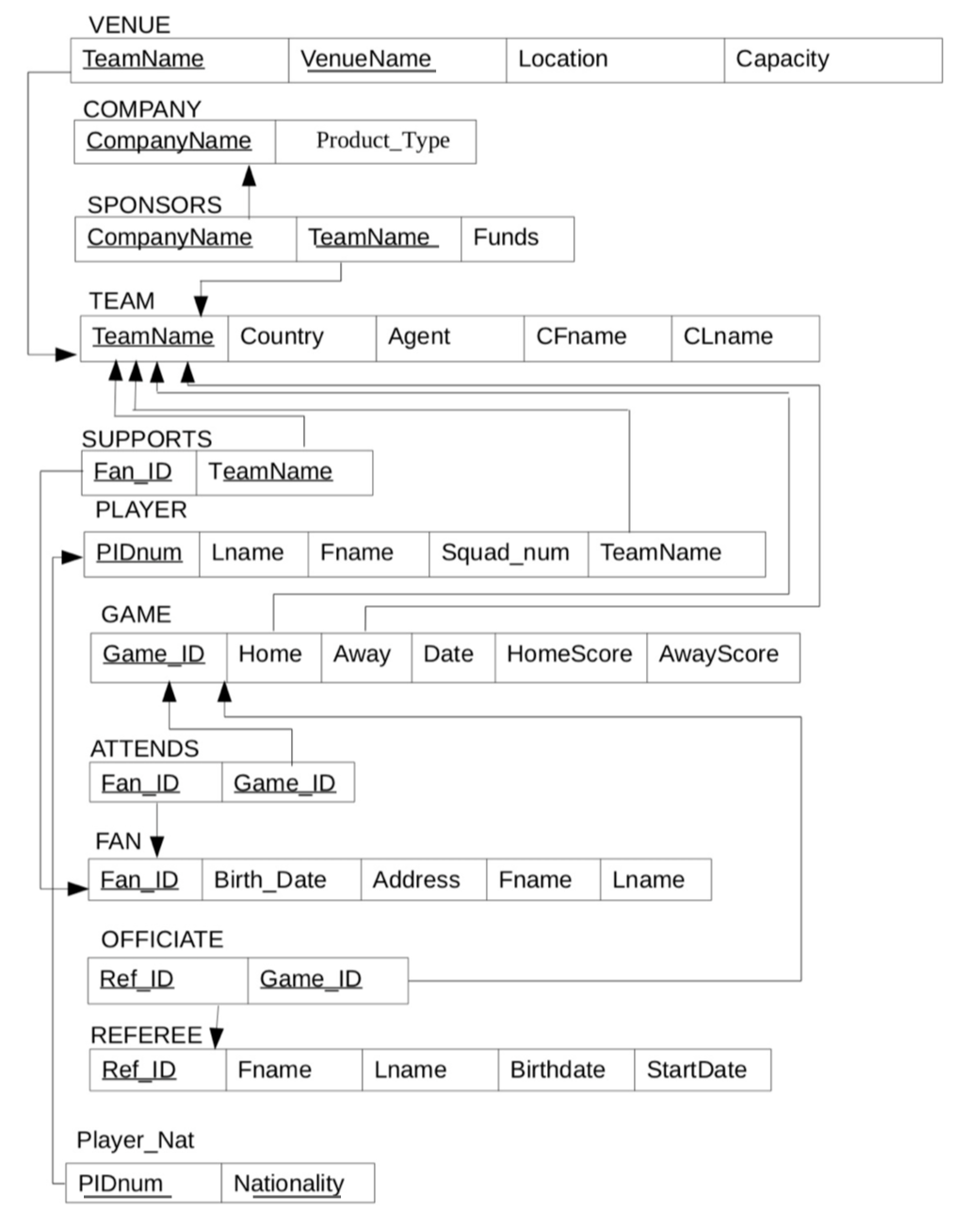

**3. Normalization**

Conceptual Note: Many entities in our miniworld have demographic data (ex. Name, birthdate, start_date…), however, combinations of demographic data are not used for keys in any of our tables. This miniworld is meant to represent professional soccer leagues, which is an enormous amount of data. Since the input of data would not necessarily be entirely monitored, we have decided to account for the small statistical probability of two entities having matching data (ie same name and birthday). Although this is an improbable possibility, it is a possibility, and we would prefer to design our database to be able to handle it.

**VENUE (TeamName, VenueName, Location, Capacity)**

|  |  |  |  |
| --- | --- | --- | --- |
| Step1: 1NF | Step2: 2NF | Step3: 3NF | Step4: BCNF |
| All attributes are atomic | Only one primary key so already in 2NF. Need combination of TeamName and Venue name to determine Location and Capacity, and neither determines the other. | Nothing transitively dependent. | Primary key not dependent on non-primary keys. |

**COMPANY (CompanyName, Product_Type)**

|  |  |  |  |
| --- | --- | --- | --- |
| Step1: 1NF | Step2: 2NF | Step3: 3NF | Step4: BCNF |
| All attributes are atomic. | CompanyName is the only primary key, so it is in 2NF. | Product_Type is the only non-prime attribute, so it cannot be transitively dependent | Already in BCNF. |

**SPONSORS(CompanyName, TeamName, Funds)**

|  |  |  |  |
| --- | --- | --- | --- |
| Step1: 1NF | Step2: 2NF | Step3: 3NF | Step4: BCNF |
| All attributes are atomic. | CompanyName and TeamName together is the only primary key. Funds dependent on combination of both. | No transitive dependencies. | Already in BCNF. |

**TEAM (TeamName, Country, Agent, CFname, CLname)**

|  |  |  |  |
| --- | --- | --- | --- |
| Step1: 1NF | Step2: 2NF | Step3: 3NF | Step4: BCNF |
| All attributes are atomic, after splitting Coach into CFname and CLname. | TeamName is the only primary key, so already in 2NF. | Non-prime attributes are nontransitive dependent on the primary key. | Already in BCNF |

**SUPPORTS (Fan_ID, TeamName)**

|  |  |  |  |
| --- | --- | --- | --- |
| Step1: 1NF | Step2: 2NF | Step3: 3NF | Step4: BCNF |
| All attributes are atomic. | No non-prime attributes. | No non-prime attributes. | Already in BCNF |

**PLAYER(PIDnum, Lname, Fname, Squad_num, TeamName)**

|  |  |  |  |
| --- | --- | --- | --- |
| Step1: 1NF | Step2: 2NF | Step3: 3NF | Step4: BCNF |
| All attributes are atomic, after Name is is split into Lname and Fname. (Nationality was removed and given its own table as it is multi-valued) | All non-prime attributes fully dependent on primary key. | The table is lacking transitive dependencies. To determine any attribute, PIDnum must be known. | Already in BCNF. |

**GAME (Game_ID, Home, Away, Date, HomeScore, AwayScore)**

|  |  |  |  |
| --- | --- | --- | --- |
| Step1: 1NF | Step2: 2NF | Step3: 3NF | Step4: BCNF |
| All attributes are atomic, there will only be one home team and home score, and one away team and away score. | All attributes are already functionally dependent on Game_ID. | The relation is in 3NF, as there are no transitive dependencies. We are accounting for possibilities of multiple games in 1 day. | The relation is in BCNF. |

**ATTENDS (Fan_ID, Game_ID)**

|  |  |  |  |
| --- | --- | --- | --- |
| Step1: 1NF | Step2: 2NF | Step3: 3NF | Step4: BCNF |
| All attributes are atomic. | No non-prime attributes. Every Fan_ID Game_ID combination is unique, and each Fan_ID and Game_ID may appear in multiple tuples. | No non-prime attributes. | The relation is in BCNF. |

**FAN (Fan_ID, First_name, Last_name, Address, Birth_date)**

|  |  |  |  |
| --- | --- | --- | --- |
| Step1: 1NF | Step2: 2NF | Step3: 3NF | Step4: BCNF |
| All attributes are already atomic except for Name, which has been split to First and Last. | All attributes fully dependent on Fan_ID. | There are no transitive dependencies as all keys are only dependent on the primary key. We are accounting for the small possibility of 2 fans having the same demographic info. | The relation is in BCNF |

**OFFICIATE (Ref_ID, Game_ID)**

|  |  |  |  |
| --- | --- | --- | --- |
| Step1: 1NF | Step2: 2NF | Step3: 3NF | Step4: BCNF |
| All attributes are atomic. | Each tuple must be identified by the combination of Ref_ID and Game_ID. No non-prime attributes. | No non-prime attributes. | The relation is in BCNF. |

**REFEREE (Ref_ID, Fname, Lname, Birthdate, StartDate)**

|  |  |  |  |
| --- | --- | --- | --- |
| Step1: 1NF | Step2: 2NF | Step3: 3NF | Step4: BCNF |
| All attributes are atomic, following the split of Name into Fname and Lname. | Everything fully dependent on Ref_ID. | There are no transitive dependencies as all non-key attributes are only dependent on the PK. We are accounting for refs with the same demographic information. | Already in BCNF. The PK is not dependent on anything. |

**PLAYER_NAT (PIDnum, Nationality)**

|  |  |  |  |
| --- | --- | --- | --- |
| Step1: 1NF | Step2: 2NF | Step3: 3NF | Step4: BCNF |
| Attributes are atomic. | Nationality fully dependent on PIDnum. | No transitive dependencies. | Already in BCNF. PK not dependent on Nationality. |

**4. Load.sql**

DROP TABLE officiate;

DROP TABLE player_nat;

DROP TABLE attends;

DROP TABLE supports;

DROP TABLE fan;

DROP TABLE sponsors;

DROP TABLE game;

DROP TABLE venue_details;

DROP TABLE venue;

DROP TABLE referee;

DROP TABLE player;

DROP TABLE team;

DROP TABLE company;

CREATE TABLE team (

team_name VARCHAR2(20),

country VARCHAR2(15) NOT NULL,

agent VARCHAR2(15),

cfname VARCHAR2(15) NOT NULL,

clname VARCHAR2(15),

PRIMARY KEY(team_name)

);

INSERT INTO team VALUES('Real Madrid CF', 'Spain','Matthew Jones','Zinedine','Zidane');

INSERT INTO team VALUES('FC Barcelona', 'Spain','James Smith','Ernesto','Valverde');

INSERT INTO team VALUES('FC Bayern Munchen', 'Germany','Joshua Brown','Niko','Kovac');

INSERT INTO team VALUES('Juventus', 'Italy','John Smith','Maurizio','Sarri');

INSERT INTO team VALUES('Manchester City FC', 'England','Alexander Moore','Pep','Guardiola');

CREATE TABLE venue (

team_name VARCHAR2(20) REFERENCES team(team_name),

venue_name VARCHAR2(30) NOT NULL UNIQUE,

PRIMARY KEY(team_name)

);

INSERT INTO venue VALUES('Real Madrid CF','Santiago Bernabeu Stadium');

INSERT INTO venue VALUES('FC Barcelona','Camp Nou');

INSERT INTO venue VALUES('FC Bayern Munchen','Allianz Arena');

INSERT INTO venue VALUES('Juventus','Allianz Stadium');

INSERT INTO venue VALUES('Manchester City FC','Etihad Stadium');

CREATE TABLE venue_details (

venue_name VARCHAR2(30) REFERENCES venue(venue_name),

location VARCHAR2(30),

capacity NUMBER(6),

PRIMARY KEY(venue_name)

);

INSERT INTO venue_details VALUES('Santiago Bernabeu Stadium','Madrid, Spain',81044);

INSERT INTO venue_details VALUES('Camp Nou','Barcelona, Spain',99354);

INSERT INTO venue_details VALUES('Allianz Arena','Munich, Germany',70000);

INSERT INTO venue_details VALUES('Allianz Stadium','Turin, Italy',41507);

INSERT INTO venue_details VALUES('Etihad Stadium','Manchester, England',53000);

CREATE TABLE company (

company_name VARCHAR2(15),

product_type VARCHAR2(15),

PRIMARY KEY(company_name)

);

INSERT INTO company VALUES('Emirates','Uniform');

INSERT INTO company VALUES('Adidas','Equipment');

INSERT INTO company VALUES('Nike','Uniform');

INSERT INTO company VALUES('Rakuten','Merchandise');

INSERT INTO company VALUES('Beko','Merchandise');

INSERT INTO company VALUES('Telekom','Equipment');

INSERT INTO company VALUES('Audi','Uniform');

INSERT INTO company VALUES('Allianz','Merchandise');

INSERT INTO company VALUES('Jeep','Equipment');

INSERT INTO company VALUES('Etihad Airways','Merchandise');

INSERT INTO company VALUES('Puma','Merchandise');

INSERT INTO company VALUES('Nissan','Merchandise');

CREATE TABLE sponsors (

company_name VARCHAR2(15) REFERENCES company(company_name),

team_name VARCHAR2(20) NOT NULL,

funds VARCHAR2(15),

PRIMARY KEY(company_name)

);

INSERT INTO sponsors VALUES('Emirates','Real Madrid CF','Uniform');

INSERT INTO sponsors VALUES('Adidas','Real Madrid CF','Equipment');

INSERT INTO sponsors VALUES('Nike','FC Barcelona','Uniform');

INSERT INTO sponsors VALUES('Rakuten','FC Barcelona','Merchandise');

INSERT INTO sponsors VALUES('Beko','FC Barcelona','Merchandise');

INSERT INTO sponsors VALUES('Telekom','FC Bayern Munchen','Equipment');

INSERT INTO sponsors VALUES('Audi','FC Bayern Munchen','Uniform');

INSERT INTO sponsors VALUES('Allianz','FC Bayern Munchen','Merchandise');

INSERT INTO sponsors VALUES('Jeep','Juventus','Equipment');

INSERT INTO sponsors VALUES('Etihad Airways','Manchester City FC','Uniform');

INSERT INTO sponsors VALUES('Puma','Manchester City FC','Merchandise');

INSERT INTO sponsors VALUES('Nissan','Manchester City FC','Merchandise');

CREATE TABLE fan (

fan_id CHAR(7),

birth_date DATE,

address VARCHAR2(50),

fname VARCHAR2(15) NOT NULL,

lname VARCHAR2(15) NOT NULL,

PRIMARY KEY(fan_id)

);

INSERT INTO fan VALUES('1871232',TO_DATE('02-12-1998','DD-MM-YYYY'),'345 Old Nelson Road, Singapore','Govanna','Smith');

INSERT INTO fan VALUES('7418617',TO_DATE('12-11-1990','DD-MM-YYYY'),' 123 Newtown Road, Singapore', 'Giovannie','Sandro');

INSERT INTO fan VALUES('8612341',TO_DATE('30-10-1970','DD-MM-YYYY'),'118 Orchard Road, Madrid, Spain','Miguel','Brown');

INSERT INTO fan VALUES('3151235',TO_DATE('18-02-1980','DD-MM-YYYY'),'43 Nagambie-Locksley Rd, Tabilk, Australia','Contenta','Lomas');

INSERT INTO fan VALUES('6123126',TO_DATE('26-09-1965','DD-MM-YYYY'),'765 Sigerei District, Moldova','Lucas','Kirk');

INSERT INTO fan VALUES('1238512',TO_DATE('20-10-1987','DD-MM-YYYY'),'Ernst-Diegel, 36304 Alsfeld, Germany','Augustus','Clout');

INSERT INTO fan VALUES('1230723',TO_DATE('02-03-1988','DD-MM-YYYY'),'123 Surrey Lane, England','ichard','Browning');

INSERT INTO fan VALUES('1237412',TO_DATE('01-04-1991','DD-MM-YYYY'),'423 Loch Lane, Ireland','Constance','Hill');

INSERT INTO fan VALUES('5782340',TO_DATE('30-08-1978','DD-MM-YYYY'),'42 Knox Street','Bruno','Mayer');

INSERT INTO fan VALUES('4810781',TO_DATE('03-01-2000','DD-MM-YYYY'),'62 Deutshborg Avenue, Sweden','Jake','Vlodkcha');

INSERT INTO fan VALUES('7812307',TO_DATE('21-05-1972','DD-MM-YYYY'),'123 Gerald Road, Ireland','Tim','McDonald');

INSERT INTO fan VALUES('1120712',TO_DATE('22-04-1945','DD-MM-YYYY'),'7 Oldman road, Wales','Eustance','Evergreen');

INSERT INTO fan VALUES('5971823',TO_DATE('22-12-2001','DD-MM-YYYY'),'47 Route de Montastruc, 31380 Roqueseriere, France','Cedric','Gustava');

INSERT INTO fan VALUES('6123018',TO_DATE('09-08-1992','DD-MM-YYYY'),'240 Chemin des Mirabelles, 81500 Lavaur, France','Davide','Berne');

CREATE TABLE supports (

fan_id CHAR(7) REFERENCES fan(fan_id),

team_name VARCHAR2(20) NOT NULL,

PRIMARY KEY(fan_id)

);

INSERT INTO supports VALUES('1871232','Real Madrid CF');

INSERT INTO supports VALUES('8612341','Real Madrid CF');

INSERT INTO supports VALUES('1230723','Real Madrid CF');

INSERT INTO supports VALUES('1237412','Real Madrid CF');

INSERT INTO supports VALUES('1120712','Real Madrid CF');

INSERT INTO supports VALUES('7418617','Juventus');

INSERT INTO supports VALUES('3151235','Juventus');

INSERT INTO supports VALUES('6123126','FC Barcelona');

INSERT INTO supports VALUES('1238512','FC Barcelona');

INSERT INTO supports VALUES('4810781','FC Barcelona');

INSERT INTO supports VALUES('5782340','Manchester City FC');

INSERT INTO supports VALUES('7812307','Manchester City FC');

INSERT INTO supports VALUES('5971823','Manchester City FC');

INSERT INTO supports VALUES('6123018','FC Bayern Munchen');

CREATE TABLE player (

player_id CHAR(5),

lname VARCHAR2(15) NOT NULL,

fname VARCHAR2(15) NOT NULL,

squad_num NUMBER(2) NOT NULL,

team_name VARCHAR2(20) REFERENCES team(team_name),

PRIMARY KEY(player_id)

);

INSERT INTO player VALUES('42496','Hazard', 'Eden',1, 'Real Madrid CF');

INSERT INTO player VALUES('94812','Carvajal', 'Dani',2, 'Real Madrid CF');

INSERT INTO player VALUES('76121', 'Asensio', 'Marco',7, 'Real Madrid CF');

INSERT INTO player VALUES('51234','Casilla','Kiko',8, 'Real Madrid CF');

INSERT INTO player VALUES('74534','Navas','Keylor', 6, 'Real Madrid CF');

INSERT INTO player VALUES('51357', 'Rodriguez','James', 4, 'Real Madrid CF');

INSERT INTO player VALUES('93450','Kroos', 'Toni', 3, 'Real Madrid CF');

INSERT INTO player VALUES('51863','Bale','Gareth', 9, 'Real Madrid CF');

INSERT INTO player VALUES('21768','Alba','Jordi', 10, 'FC Barcelona');

INSERT INTO player VALUES('98723','Mascherano','Javier', 11, 'FC Barcelona');

INSERT INTO player VALUES('60456','Villa','David', 8, 'FC Barcelona');

INSERT INTO player VALUES('89764','Busques','Sergio',5, 'FC Barcelona');

INSERT INTO player VALUES('30984','Keitta','Seydou',7, 'FC Barcelona');

INSERT INTO player VALUES('65740','Alves','Dani',3, 'FC Barcelona');

INSERT INTO player VALUES('49810','Abidal','Eric',2, 'FC Barcelona');

INSERT INTO player VALUES('35701','Coman','Kingsley', 10,'FC Bayern Munchen');

INSERT INTO player VALUES('56701','Bernat','Juan', 6,'FC Bayern Munchen');

INSERT INTO player VALUES('23426','Lewandowski','Robert', 8,'FC Bayern Munchen');

INSERT INTO player VALUES('77810','Shaqiri','Xherdan',3,'FC Bayern Munchen');

INSERT INTO player VALUES('22969','Gustavo', 'Luiz',2,'FC Bayern Munchen');

INSERT INTO player VALUES('66445','Neuer', 'Manuel', 1,'FC Bayern Munchen');

INSERT INTO player VALUES('23490','Contento','Diego', 4,'FC Bayern Munchen');

INSERT INTO player VALUES('97406','Alaba', 'David',5,'FC Bayern Munchen');

INSERT INTO player VALUES('98269','Robben', 'Arjen',7,'FC Bayern Munchen');

INSERT INTO player VALUES('33481','Badstuber', 'Holger',9,'FC Bayern Munchen');

INSERT INTO player VALUES('35716','Tymoshchuk','Anatoliy',11,'FC Bayern Munchen');

INSERT INTO player VALUES('98761','Cuadrado','Juan',2,'Juventus');

INSERT INTO player VALUES('49833','Dybala','Paulo', 9,'Juventus');

INSERT INTO player VALUES('68701','Khedira','Sami',11,'Juventus');

INSERT INTO player VALUES('65711','Sandro', 'Alex', 8,'Juventus');

INSERT INTO player VALUES('11233','Asamoah', 'Kwadwo', 3, 'Juventus');

INSERT INTO player VALUES('35674','Padoin', 'Simone', 5, 'Juventus');

INSERT INTO player VALUES('98613','Pogba', 'Paulo', 4, 'Juventus');

INSERT INTO player VALUES('35403','Barzagli', 'Andrea', 6,'Juventus');

INSERT INTO player VALUES('57464','Lichtsteiner','Stephan',7,'Juventus');

INSERT INTO player VALUES('66587','Horlock', 'Kevin', 3,'Manchester City FC');

INSERT INTO player VALUES('32412','Whitley','Jeff', 9,'Manchester City FC');

INSERT INTO player VALUES('37854','Brown', 'Michael', 2,'Manchester City FC');

INSERT INTO player VALUES('98884','Kinkladze', 'Giorgi', 4,'Manchester City FC');

INSERT INTO player VALUES('23319','Symons','Kit', 4,'Manchester City FC');

INSERT INTO player VALUES('12345','Summerbee', 'Nicky', 10,'Manchester City FC');

INSERT INTO player VALUES('98756','Edghill', 'Richard', 11,'Manchester City FC');

INSERT INTO player VALUES('99945','Lomas','Steve',1,'Manchester City FC');

INSERT INTO player VALUES('11123','Flitcroft','Garry', 7,'Manchester City FC');

CREATE TABLE game (

game_id CHAR(4),

home VARCHAR2(30) REFERENCES team(team_name),

away VARCHAR2(30) REFERENCES team(team_name),

game_date DATE,

home_score NUMBER(3) NOT NULL,

away_score NUMBER(3) NOT NULL,

PRIMARY KEY(game_id)

);

INSERT INTO game VALUES('3215','Real Madrid CF','FC Barcelona',TO_DATE('06-05-2019','DD-MM-YYYY'),2,7);

INSERT INTO game VALUES('8943','Juventus','FC Bayern Munchen',TO_DATE('12-07-2019','DD-MM-YYYY'),4,1);

INSERT INTO game VALUES('3247','Manchester City FC','Real Madrid CF',TO_DATE('08-05-2019','DD-MM-YYYY'),2,3);

INSERT INTO game VALUES('3573','FC Barcelona','FC Bayern Munchen',TO_DATE('13-07-2019','DD-MM-YYYY'),4,5);

INSERT INTO game VALUES('1267','Real Madrid CF','FC Bayern Munchen',TO_DATE('18-05-2019','DD-MM-YYYY'),11,3);

INSERT INTO game VALUES('7626','FC Barcelona','Juventus',TO_DATE('11-02-2019','DD-MM-YYYY'),2,2);

INSERT INTO game VALUES('4156','FC Barcelona','Manchester City FC',TO_DATE('16-04-2019','DD-MM-YYYY'),6,7);

INSERT INTO game VALUES('6785','FC Bayern Munchen','Real Madrid CF',TO_DATE('02-08-2019','DD-MM-YYYY'),4,4);

INSERT INTO game VALUES('1442','Juventus','FC Barcelona',TO_DATE('11-06-2019','DD-MM-YYYY'),8,6);

INSERT INTO game VALUES('1067','Juventus','Real Madrid CF',TO_DATE('03-03-2019','DD-MM-YYYY'),12,12);

INSERT INTO game VALUES('7698','Real Madrid CF','Manchester City FC',TO_DATE('01-05-2019','DD-MM-YYYY'),4,14);

INSERT INTO game VALUES('7562','FC Bayern Munchen','Juventus',TO_DATE('06-06-2019','DD-MM-YYYY'),5,2);

CREATE TABLE attends (

fan_id CHAR(7) REFERENCES fan(fan_id),

game_id CHAR(4) REFERENCES game(game_id),

PRIMARY KEY(fan_id, game_id)

);

INSERT INTO attends VALUES ('1871232','3215');

INSERT INTO attends VALUES ('3151235','7626');

INSERT INTO attends VALUES ('7418617','3215');

INSERT INTO attends VALUES ('6123126','1067');

INSERT INTO attends VALUES ('1238512','7698');

INSERT INTO attends VALUES ('4810781','7562');

INSERT INTO attends VALUES ('5782340','3215');

INSERT INTO attends VALUES ('5971823','1067');

CREATE TABLE referee (

ref_id CHAR(4),

fname VARCHAR2(15) NOT NULL,

lname VARCHAR2(15) NOT NULL,

birth_date DATE,

start_date DATE NOT NULL,

PRIMARY KEY(ref_id)

);

INSERT INTO referee VALUES('0001','Andreas', 'Ekberg', TO_DATE ('02-01-1985','DD-MM-YYYY'), TO_DATE ('10-08-2019','DD-MM-YYYY'));

INSERT INTO referee VALUES('0013','Ramy', 'Touchan', TO_DATE ('14-08-1988','DD-MM-YYYY'), TO_DATE ('20-07-2019','DD-MM-YYYY'));

INSERT INTO referee VALUES('0069','Timothy', 'Ford', TO_DATE ('14-08-1980','DD-MM-YYYY'), TO_DATE ('23-07-2019','DD-MM-YYYY'));

INSERT INTO referee VALUES('0075','Wilton','Sampaio', TO_DATE ('25-12-1981','DD-MM-YYYY'), TO_DATE ('19-12-2018','DD-MM-YYYY'));

INSERT INTO referee VALUES('0023','Jan','Wegereef', TO_DATE ('17-01-1962','DD-MM-YYYY'), TO_DATE ('05-06-2004','DD-MM-YYYY'));

INSERT INTO referee VALUES('0093','Roberto','Rosetti', TO_DATE ('18-09-1967','DD-MM-YYYY'), TO_DATE ('01-06-2004','DD-MM-YYYY'));

INSERT INTO referee VALUES('0176','Deniz','Aytekin', TO_DATE ('21-07-1978','DD-MM-YYYY'), TO_DATE ('22-05-2016','DD-MM-YYYY'));

INSERT INTO referee VALUES('0917','Gianluca','Rocchi', TO_DATE ('25-08-1973','DD-MM-YYYY'), TO_DATE ('20-04-2019','DD-MM-YYYY'));

INSERT INTO referee VALUES('0824','Mauro','Tonolini', TO_DATE ('25-08-1980','DD-MM-YYYY'), TO_DATE ('12-01-2018','DD-MM-YYYY'));

INSERT INTO referee VALUES('0726','Danny','Makkelie', TO_DATE ('13-08-1985','DD-MM-YYYY'), TO_DATE ('12-12-2017','DD-MM-YYYY'));

INSERT INTO referee VALUES('0515', 'Massimilianol', 'Irrati', TO_DATE ('01-01-1979', 'DD-MM-YYYY'), TO_DATE ('01-12-2017','DD-MM-YYYY'));

INSERT INTO referee VALUES('0414', 'Bruno', 'Boschilia', TO_DATE ('07-04-1978', 'DD-MM-YYYY'), TO_DATE ('30-11-2017','DD-MM-YYYY'));

INSERT INTO referee VALUES('0313', 'Matthew', 'Conger', TO_DATE ('19-09-1984', 'DD-MM-YYYY'), TO_DATE ('30-06-2004','DD-MM-YYYY'));

INSERT INTO referee VALUES('0212', 'Toru', 'Sagara', TO_DATE ('10-11-1985', 'DD-MM-YYYY'), TO_DATE ('18-06-2004','DD-MM-YYYY'));

INSERT INTO referee VALUES('0101', 'Frank', 'Anderson', TO_DATE ('10-04-1975', 'DD-MM-YYYY'), TO_DATE ('19-06-2004','DD-MM-YYYY'));

CREATE TABLE officiate (

ref_id CHAR(4) REFERENCES referee(ref_id),

game_id CHAR(4) REFERENCES game(game_id),

PRIMARY KEY(ref_id)

);

INSERT INTO officiate VALUES ('0001','3215');

INSERT INTO officiate VALUES ('0023','3215');

INSERT INTO officiate VALUES ('0075','8943');

INSERT INTO officiate VALUES ('0069','3247');

INSERT INTO officiate VALUES ('0013','3573');

INSERT INTO officiate VALUES ('0093','1267');

INSERT INTO officiate VALUES ('0176','3573');

INSERT INTO officiate VALUES ('0917','7626');

INSERT INTO officiate VALUES ('0824','4156');

INSERT INTO officiate VALUES ('0726','1067');

INSERT INTO officiate VALUES ('0515','1442');

INSERT INTO officiate VALUES ('0414','7562');

INSERT INTO officiate VALUES ('0313','1067');

INSERT INTO officiate VALUES ('0101','7698');

CREATE TABLE player_nat (

player_id CHAR(5) REFERENCES player(player_id),

nationality VARCHAR2(30),

PRIMARY KEY(player_id)

);

INSERT INTO player_nat VALUES('42496', 'Belgium');

INSERT INTO player_nat VALUES('94812', 'Spain');

INSERT INTO player_nat VALUES('76121', 'Spain');

INSERT INTO player_nat VALUES('51234', 'Spain');

INSERT INTO player_nat VALUES('74534', 'Costa Rica');

INSERT INTO player_nat VALUES('51357', 'Colombia');

INSERT INTO player_nat VALUES('93450', 'Germany');

INSERT INTO player_nat VALUES('51863', 'Wales');

INSERT INTO player_nat VALUES('21768', 'Spain');

INSERT INTO player_nat VALUES('98723', 'Argentina');

INSERT INTO player_nat VALUES('60456', 'Spain');

INSERT INTO player_nat VALUES('89764', 'Spain');

INSERT INTO player_nat VALUES('30984', 'Mali');

INSERT INTO player_nat VALUES('65740', 'Brazil');

INSERT INTO player_nat VALUES('49810', 'France');

INSERT INTO player_nat VALUES('56701', 'Spain');

INSERT INTO player_nat VALUES('35701', 'France');

INSERT INTO player_nat VALUES('23426', 'Poland');

INSERT INTO player_nat VALUES('77810', 'Switzerland');

INSERT INTO player_nat VALUES('22969', 'Brazil');

INSERT INTO player_nat VALUES('66445', 'Germany');

INSERT INTO player_nat VALUES('97406', 'Austria');

INSERT INTO player_nat VALUES('33481', 'Germany');

INSERT INTO player_nat VALUES('98761', 'Colombia');

INSERT INTO player_nat VALUES('49833', 'Argentina');

INSERT INTO player_nat VALUES('68701', 'Germany');

INSERT INTO player_nat VALUES('65711', 'Brazil');

INSERT INTO player_nat VALUES('11233', 'Ghana');

INSERT INTO player_nat VALUES('35674', 'Italy');

INSERT INTO player_nat VALUES('98613', 'France');

INSERT INTO player_nat VALUES('35403', 'Switzerland');

INSERT INTO player_nat VALUES('57464', 'Italy');

INSERT INTO player_nat VALUES('32412', 'Northern Ireland');

INSERT INTO player_nat VALUES('66587', 'Northern Ireland');

INSERT INTO player_nat VALUES('37854', 'England');

INSERT INTO player_nat VALUES('98884', 'Georgia');

INSERT INTO player_nat VALUES('23319', 'Wales');

INSERT INTO player_nat VALUES('12345', 'England');

INSERT INTO player_nat VALUES('98756', 'England');

INSERT INTO player_nat VALUES('99945','North Ireland');

INSERT INTO player_nat VALUES('11123', 'England');

COMMIT;

**5. Teamwork Summary**

To complete assignment 2, we met twice as a group and also worked independently. At the first meeting, we collaborated to make changes to our ER Diagram. Between the first and second meetings, we all individually planned out how to normalize and create a schema. At the second meeting we created the schema and discussed normalization. To finish the project, we divided up tasks amongst ourselves. Since we had discussed normalization as a group, we decided to have Celes and Poppy write a first draft of our normalization process and have Mark and Stephen review and edit it. Mark also wrote out the justifications for changes to the ER Diagram that had been discussed at meeting 2. Stephen was responsible for collecting data to create the tables with. Everyone wrote and edited a few SQL statements. As the group leader, Mark wrote the teamwork summary. Frequent emails and Google Drive were used for collaboration by all.